|  |
| --- |
| URMMA |
| Risk Advisor |
| November 2016 |

|  |
| --- |
| UTAH RISK MANAGEMENT MUTUAL ASSOCIATION ● SERVING UTAH MUNICIPALITIES |

|  |
| --- |
| **IN THIS ISSUE**  MESSAGE FROM BOARD CHAIRMAN Error! Bookmark not defined. |
| CHAIRMAN OF THE BOARD MESSAGE **1**  THE INSPECTION PROGRAM **2**  AUTO PHYSICAL DAMAGE COVERAGE **3**  URMMA UPCOMING EVENTS…….**4**  2016 SUMMER CONFERENCE AT BEAR LAKE **4**  CHANGES TO THE EXECUTIVE COMMITTEE.……………………………. **4**  INTRODUCTION TO URMMA’S STAFF **5**  URMMA’S CONTRACTED SERVICE PROVIDERS **5**  FREQUENTLY ASKED QUESTIONS **6** |

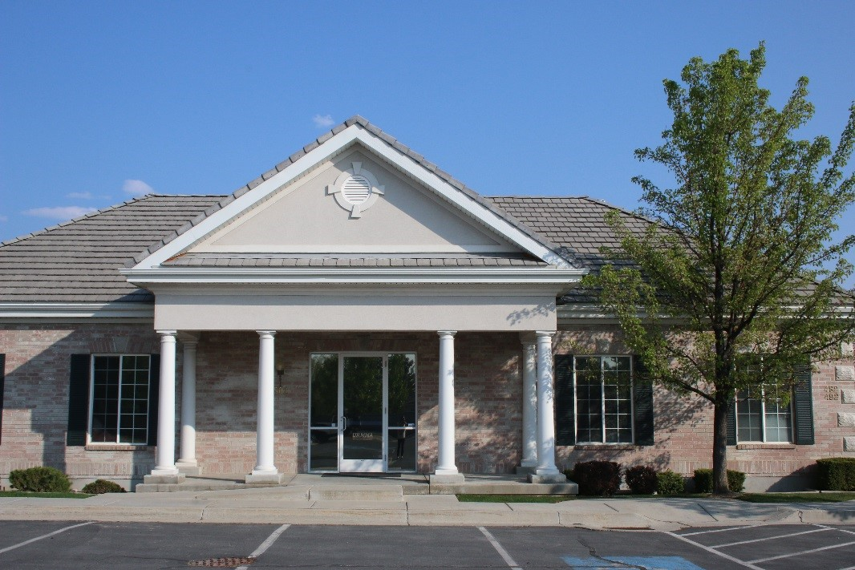

### **CHAIRMAN OF THE BOARD MESSAGE**

BY JAMIE DAVIDSON

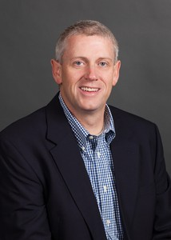Last week, I was disappointed to read about two workers who lost their lives in local, work related construction incidents. Both deaths involved heavy equipment and soils that had sluffed off the side of a trench or a future home foundation wall. Even more concerning was the suggestion that not all available safety equipment was in use and/or not all protocols were followed in doing the work. These accidents are terribly unfortunate and will literally alter the lives of many people moving forward.

These incidents have reinforced to me the need to be vigilant with our employees in helping them to follow all safety protocols and in taking advantage of all available and necessary safety equipment. May I also suggest that safety is not something that should only be addressed on work sites. Rather, all of us as municipal employees, can do our part in developing a safety culture within our respective organizations and communities. Consider the following safety practices that can enhance and/or serve as a foundation for a risk-conscious and safety-oriented city:

1. Always drive with a seat belt
2. Abide by your organization’s cell phone/texting policy (no manipulation of a cell phone while driving)
3. Wear appropriate safety/protective clothing in public rights-of-way and/or work sites
4. Always back vehicles with a spotter
5. Use appropriate traffic controls when working on city streets and rights-of-way
6. Take the opportunity to make “everyday a training day,” as suggested by Gordon Graham
7. Report workplace hazards to supervisory staff
8. Enforce your organization’s drug-free workplace policy
9. Follow your police department’s pursuit and use-of-force policies
10. Use proper lifting techniques when engaged in work activities

The noted suggestions above are not a finite list of “dos” and “don’ts,” but can serve to mitigate workplace injuries and accidents. I am proud of URMMA’s commitment to safety and appreciate our association’s efforts to make workplace safety practices a priority, whether it be through our newly revised inspection program or the recently introduced URMMA University online employee training resources. These efforts help to keep our employees safe and available to serve and represent those within our respective communities.

Thanks for your commitment to URMMA and safe work practices. Have a safe and enjoyable fall season.

**[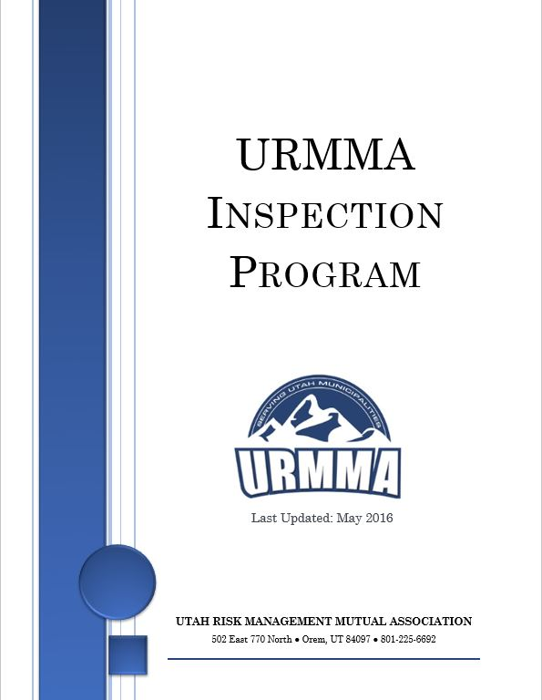](http://www.urmma.org/wp-content/uploads/2016/03/URMMA-Inspection-Program-16-17.pdf)**Jamie

### **THE INSPECTION PROGRAM**

BY JASON DAVIS

Initial inspections are in full swing. This is the first time we have done inspections with the new Inspection Program. In addition to a few new items we are looking at, I have realized that some of you are not accustomed to a thorough inspection of your cities. Please don’t be dismayed if I give you a list of lots of things that need to be corrected. Your scores will not likely be as high as they have been in the past. There are a couple of things I’d like to remind you of as we proceed with the inspections.

(1) My inspection this fall is a preliminary inspection, and is not the final score for the year. I will be re-inspecting in the spring, which gives you the opportunity to correct deficiencies before then.

(2) The purpose of the inspections is to help you and me detect potential exposure and then devise a plan to eliminate the exposure. We certainly understand that you will not have the budget available in the current fiscal year to fix all the problems. We are hoping that you can fix some of them and then make a plan to get to the others when you can. If there is a glaring safety problem at one of your facilities, and you can’t get it fixed right away, you may want to consider reducing or eliminating access to it until you can correct the problem.

Some of the fixes won’t cost you anything, you just have to do something (like police training, for example).

(3) We don’t want the inspection score to hit your premiums hard. Our goal is to use the Inspection Program as a help, not as a punishment. We will be looking at ways to adjust the final scores so that you don’t get hammered with next year’s premiums.

(4) I encourage managers and department heads or other supervisors to accompany me on the inspections (in addition to the city’s risk manager). That way you’ll be seeing what I’m seeing and we can talk about issues on the spot.

(5) Some of you have asked about a model policy for light duty for pregnant employees. We have drafted a policy with the help of outside counsel and are currently in the process of getting it reviewed by a few city attorneys. We will distribute it to you once we have that finalized, and then you will all get the point in the inspection score as long as you adopt the policy.

Here are a few things that I have been noticing cities having difficulties with:

* Daily police training.
* Backing in. (We have only had 3 backing claims since we instituted the policy, and those were all from employees who didn’t back in.)
* Dangerous playground equipment, usually from not enough soft ground material.
* Identifying 5 issues lying in wait.
* Setting up your city-wide goal for the year.
* Safety netting at baseball fields to protect spectators and avoid balls coming from other diamonds and knocking out somebody watching a game.
* Putting guardrails on bleachers over 30 inches in height.

There are a couple of issues that we are noticing that are not included in the current Inspection Program (look for them to appear in future versions).

* Securely anchoring soccer goal posts.
* Unfenced skate parks. These are dangerous if there is a steep drop-off that a child or unsuspecting person could stumble into, especially in the dark.

Thank you all for your excellent cooperation in getting these inspections done. I have thoroughly enjoyed my interactions and working with you.

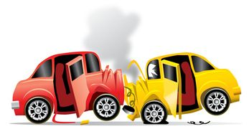Jason

### **AUTO PHYSICAL DAMAGE COVERAGE**

BY ELIZABETH CHRISTENSEN

**Vehicles Valued Under $50,000…**

Many of you understand the optional benefit available to you through URMMA’s Auto Physical Damage Coverage. We currently have hundreds of your vehicles insured. It’s a great option for inexpensive physical damage coverage for all city owned vehicles and keeps you compliant with lease requirements to provide physical damage coverage. For those of you not currently using this coverage, let me take a moment to explain the ease and convenience of this simple benefit that is open to you as an URMMA Member City.

For an annual premium of $199 per vehicle, the URMMA Auto Physical Damage Coverage Package will cover comprehensive & collision physical damage to member owned or leased vehicles. (Valued under $50,000) URMMA maintains a list of the vehicles YOU specify. Coverage follows the Fiscal Year billing schedule. (July 01 – June 30 of each year.) However, vehicles can be added at any time throughout the year at a pro-rated amount. Coverage is limited to cash value, not replacement value of the vehicle and has a per vehicle deductible of $1,000. The coverage is NOT subject to the Repayment Program and participation is completely voluntary. Auto Physical Damage Coverage is billed separately from your annual premium.

If you would like to add this benefit or have questions about your existing coverage, please give me a call at 801-225-6692!

Elizabeth

**SIGN UP FOR URMMA’S AUTO PHYSICAL DAMAGE COVERAGE**

Submit a list of vehicles for which you would like coverage to Elizabeth Christensen with the following information:

● Vehicle Description

● Vehicle Identification Number

● Vehicle Value

**IT’S AS EASY AS THAT!**

Have questions? Contact Elizabeth at [elizabeth@urmma.org](mailto:elizabeth@urmma.org)

### **2016 SUMMER CONFERENCE AT BEAR LAKE**



**URMMA’S**

**UPCOMING EVENTS**

**GORDON GRAHAM**

March 09, 2017

*(tentative date)*

**SUMMER CONFERENCE 2017 IN CEDAR CITY**

August 9th through 11th, 2017

**ANNUAL GOLF TOURNAMENT**

September 2017

VISIT OUR WEBSITE AT

[WWW.URMMA.ORG](http://WWW.URMMA.ORG)

FOR ADDITIONAL DETAILS



BY PAUL JOHNSON

In August we had a successful summer conference and we express our appreciation to board members and other city employees for your attendance and participation. The venue was great and hopefully you had an opportunity to enjoy Bear Lake. Juanito Bandito was hilarious as usual, and we thought the training was exceptional. Training topics included: personnel law, governmental immunity, police liability issues, drones and transgender issues. We also had presentations on the new inspection program and the new online training program, as well as a review of where we are getting our claims and lawsuits and where we’re spending the money. I hope you enjoyed Dr. Jeff Thompson and his keynote presentation on Wednesday regarding finding and enjoying your employment calling.

I would like to thank the rest of the URMMA staff for their tireless efforts in planning and making the arrangements for the conference. In my view, their hard work showed and the conference was both educational and enjoyable. I also appreciate your patience with us while we got the meeting room figured out. Once we moved downstairs, things went better. This venue had not ever hosted a conference like ours and there were a few bugs to work out, but once we figured it out, everything was good.

We look forward to next year’s conference and Board meeting which will be held in Cedar City, August 9th through 11th. Our meetings will be held in the City’s Heritage Conference Center. We are in the process of tying up the entire Best Western Plus, which has been recently remodeled and sits within a block of the meeting venue. Information on reserving your spot will be forthcoming. Come and enjoy another great conference and experience the new Englestad Shakespeare theatre.

Please let us know if we can do anything to make your experience with URMMA better!

Paul

**CHANGES TO THE EXECUTIVE COMMITTEE**

We would like to thank the following individuals for their service:

* Rick Holman – *Cedar City*
* Cory Branch – *Mapleton City*
* Rodger Worthen – *Riverdale City*

We would like to welcome the following individuals to the Executive Committee:

* Joe Decker – *Kanab City*
* Dave Millheim – *Farmington City*
* Seth Perrins – *Spanish Fork City*

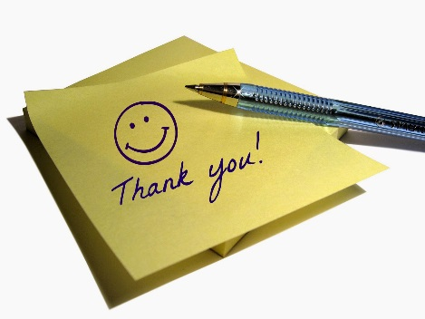

### **INTRODUCTION TO URMMA’S STAFF**

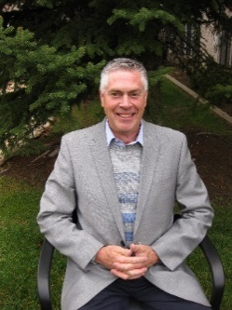

**PAUL JOHNSON** – *CEO*

I was appointed CEO of URMMA in June of 2014. Prior to that, I was URMMA’s Claims and Litigation Manager for 2.5 years. Before coming to URMMA, I worked in the Legal Services Department in the City of Orem for 30 years, with the last 26 as the City Attorney. It is my responsibility to provide leadership and direction on the operational side of URMMA. I implement policies of the Board of Directors and work to ensure that URMMA is meeting the needs of its member cities.

[*paul@urmma.org*](mailto:paul@urmma.org)

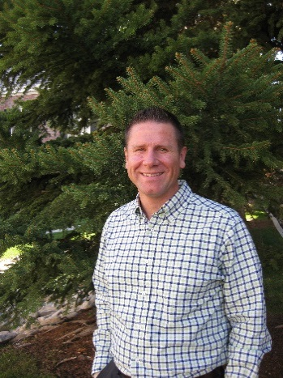

**JASON DAVIS** – *LOSS CONTROL MANAGER*

I implement URMMA’s Inspection Program for our Member Cities and provide guidance on ways to decrease liability claims. I am also responsible for providing training opportunities and recently set up the URMMA Online Training University as a useful tool to be used by our members to better train their employees. I am always happy to answer any questions you might have and look forward to serving you.

[*jason@urmma.org*](mailto:jason@urmma.org)

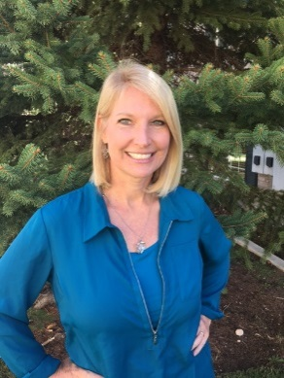

**ELIZABETH CHRISTENSEN** – *SECRETARY & TREASURER*

I started working at URMMA in early October of 2015 as the Secretary and Treasurer. I handle the financial aspects of URMMA. Some of my duties include providing our members with their Premiums as well as their Loss Triangles for the Repayment Program, handling the Auto Physical coverage offered by URMMA and processing payments for claims. I am happy to assist you in any way that I can.

[*elizabeth@urmma.org*](mailto:elizabeth@urmma.org)

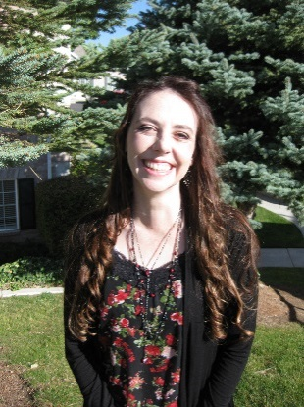

**CAMIE SHEPHERD** – *ADMINISTRATIVE ASSISTANT*

I handle the information that is input into our claims management system by setting up claims and entering information as I receive it. I upload documents to claims as well. I also issue Certificates of Liability Insurance when requested. I look forward to helping our members with any needs they may have. Feel free to contact me with any questions.

[*camie@urmma.org*](mailto:camie@urmma.org)

### **URMMA’S CONTRACTED SERVICE PROVIDERS**

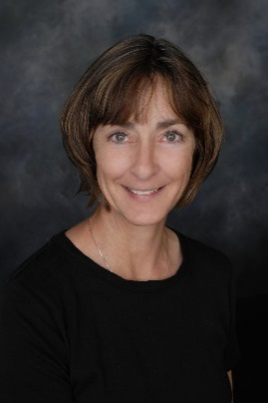

**LIBBY LOWTHER of Lowther and Associates** – *CLAIMS & LITIGATION MANAGER*

I started serving as URMMA’s Claims and Litigation Manager in September of 2014. For over 40 years, I have investigated and handled multiple types of claims throughout Utah, working for the insurance industry, self-insured corporations and governmental entities. I work with defense counsel and manage litigation on cases for URMMA. If you have an accident or get a claim, please call me. I can investigate the incident and guide you through the process at no charge to you.

*libby@lowtherassoc.com*

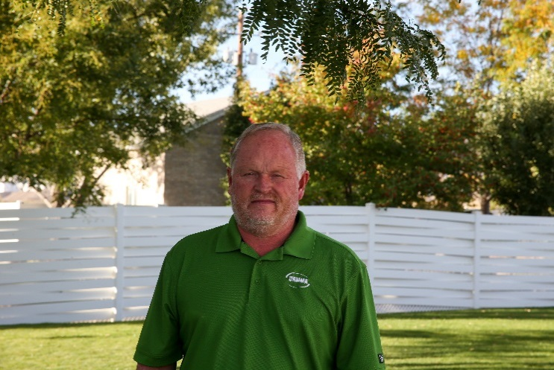

**DAVE SANDERSON of DS Accounting Services** – *ACCOUNTANT & FINANCIAL ADVISOR*

I started my own accounting business in 1988. I’ve spent over 30 years in governmental accounting. I provide general financial services for URMMA as a whole. My accounting services include monthly reconciliations, annual budgets, financial reports for board meetings and year end closing entries for the annual audit. I also provide state compliance on reporting and transparency reporting.

*dave@dsaccounting.net*

### **FREQUENTLY ASKED QUESTIONS**

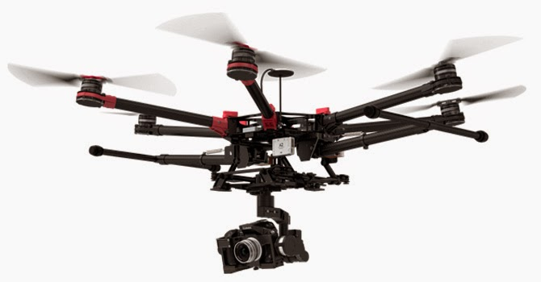

Q. Our city would like to purchase and use a drone. What needs to be done in order for it to be covered by URMMA? What will the liability coverage be?

A. Drone operations are covered only to the extent that the Member has procured an FAA Certificate of Authority for the drone operator and has adopted a policy which is written in accordance with federal and state law guidelines, and the drone at the time of the occurrence is being used by an authorized operator within the policy. Collisions with aircraft are excluded from coverage.

* Policies should state when, where and by whom the drone will/won’t be operated

Liability coverage through URMMA for drones is $6,000,000 per occurrence, no aggregate.

Do you have a question you would like URMMA to answer? Submit it to Camie Shepherd at [*camie@urmma.org*](mailto:camie@urmma.org)

**Thank you for being a valued Member of URMMA! We appreciate your support!**